Inventory Tab

A new tab labeled Inventory exists on your Digital Cookie Dashboard



Depending on the time of the sale and your council’s offerings, it may contain two sections:

Initial Cookie Order
Girl Scout Delivery Settings

Initial Cookie Order
May not be available in your Girl Scout Council based on sale format and deadlines.


When your Girl Scout has collected orders on her paper order card and it is time to submit the order to your Troop Leader/Troop Cookie Manager, you can enter her order on the Initial Cookie Order Entry section.

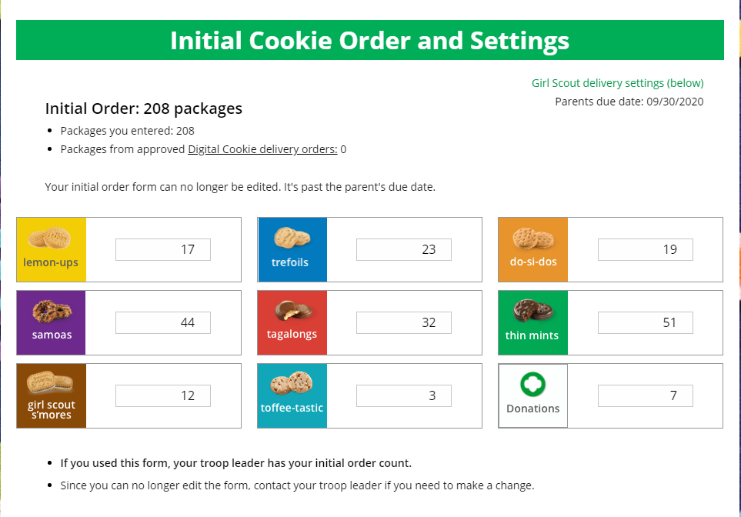

Simply enter your totals by variety prior to the Parents Due Date noted in the upper right hand corner of the section. After the due date, you can’t make edits to the numbers on this page/

NOTE: The package totals entered here do not automatically transmit to the Troop Cookie Manager’s order entry system. Please confirm with the Cookie Manager that she has received and viewed your order.

Girl Scout Delivery Settings
May not be available in your Girl Scout Council based on sale format and deadlines.


Your council may be giving you the opportunity to turn off girl delivery and off varieties of cookies. This might be useful if you run out of a variety of cookie and can’t get any more to fill customer orders, or are entirely out of cookies for delivering to customers or otherwise are unable to deliver cookies to customers.
If you are worried about your inventory, always check with your troop cookie manager first to see if you can get more cookies before turning a variety off so a customer doesn’t have the option to purchase it for delivery.

When you know you need to turn off delivery or a variety(ies), go to the bottom of your inventory tab and find the Delivery Settings section.

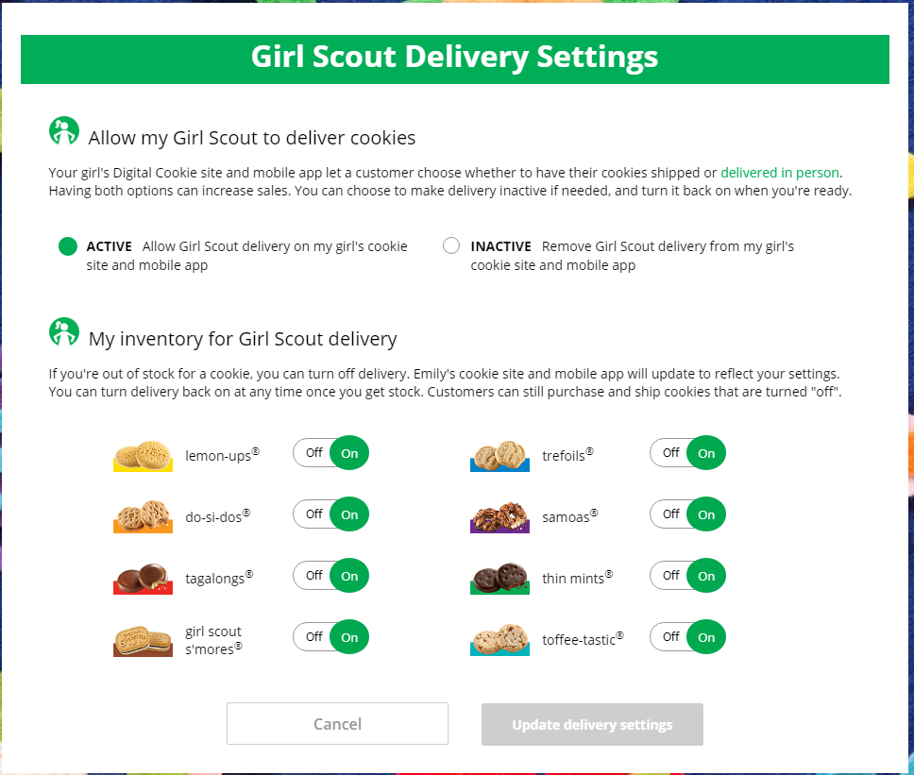



When you select “inactive” to turn off the girl delivery option for your customer, you will get a warning message. If you want to turn them off, click “Update delivery settings”.

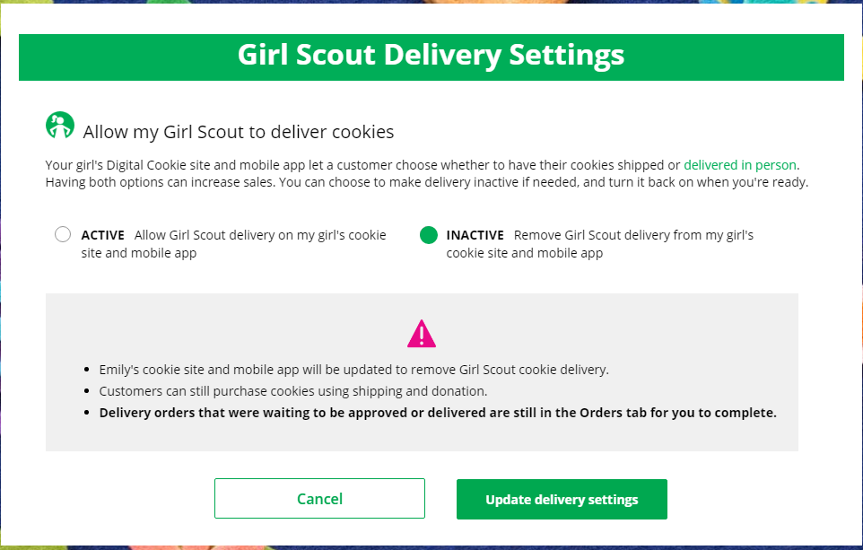

Once you have turned it to inactive, the varieties section will be removed and is superseded by the active/inactive setting. You do not need to turn off each of the varieties individually if you set it to inactive.

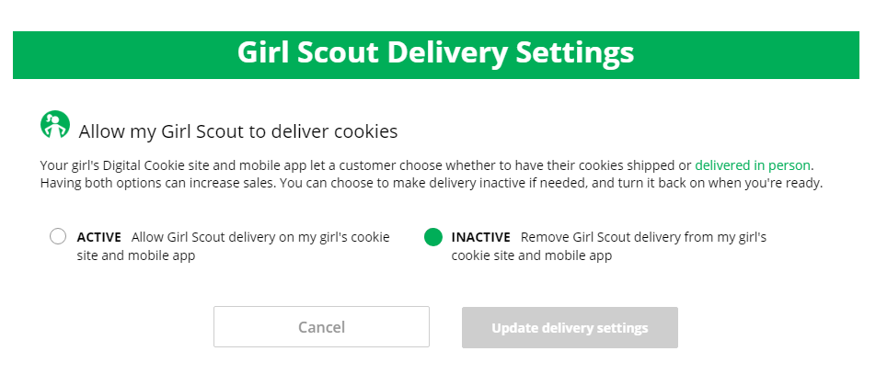

Should you wish to turn delivery back on, simply click “active” and your customers will see delivery as an option again.


If you wish to offer delivery but are out of a variety of cookie and can’t get more inventory, you can turn off just that variety of cookie for delivery and customers can only purchase those for shipping and not delivery.
To do that, simply click the “off” button and it will remove that variety from delivery option. If you are able to offer that to customers again, click the “on” and turn it back on.

